According to International Civil Aviation Organization (ICAO), Manual / Hand written passport (Non-MRP) will phase out with effect from 25th November, 2015. Foreign governments may deny visa or entry to persons traveling on manual passports after November 24, 2015.

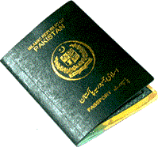
Machine Readable Passports (MRPs) are issued in conformity with International Civil Aviation Organization (ICAO) standards. Ever since the installation of Machine Readable Passport (MRP) facility at the Consulate General of Pakistan Toronto, issuance of manual passports has been phased out. Machine Readable Passport (MRP) are currently being issued from Consulate General of Pakistan Toronto.
MRP office operates on the principal of live data capturing so applicants? presence (with required documents) is compulsory to process the application.
Applicants Token, Photo, Biometric, data entry, signature and thumb impression capturing are done by trained MRP staff using latest technology.
Applicants DO NOT need any application forms or photographs for MRP applications as it is done by MRP staff during application process.
Applicants DO NOT require any prior appointment for MRP application. They will be entertained on first come first served basis during application processing time.
Click the following links for information on MRP:
Requirements for applying for a New MRP or Renewal of MRP
Application in the event of Loss of Passport
MRP Collection - Delivery of your MRP / Fees / Processing Time

